**Output :**

* 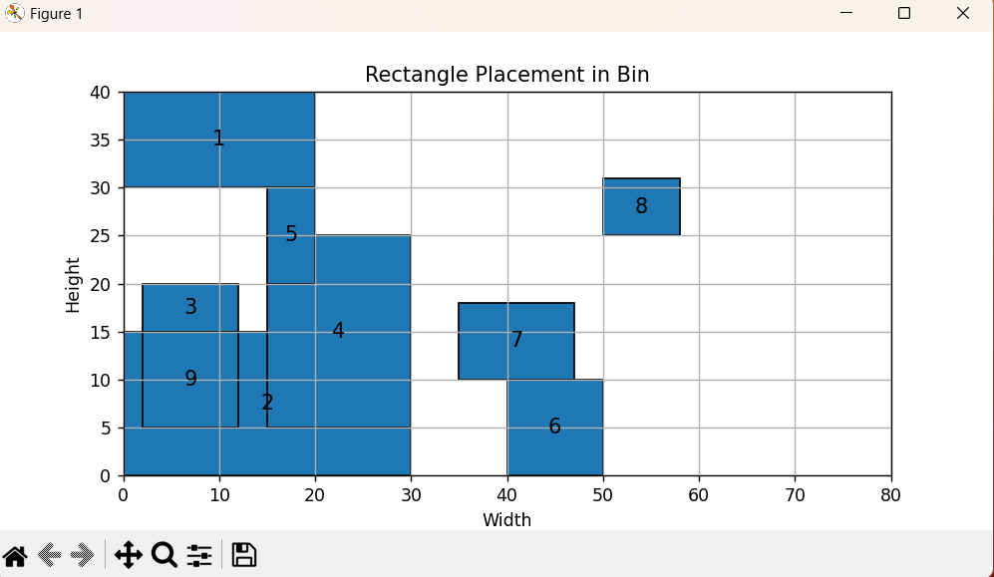**Graph Arrangement as per requirement**